-- Sales_Order_Detail

CREATE TABLE Sales_Order_Detail(

SalesID CHAR(10) NOT NULL,

ItemID CHAR(10) NOT NULL,

ItemName VARCHAR(50),

Unit VARCHAR(10),

Quantity INT,

Price DECIMAL(10, 2),

Amount DECIMAL(12, 2)

);

-- Insert values into table of “Sales_Order_Detail”

insert into Sales_Order_Detail (SalesID, ItemID, ItemName, Unit, Quantity, Price, Amount ) values (1, 1, 'X-Box', 1, 5, 100, 20);

insert into Sales_Order_Detail (SalesID, ItemID, ItemName, Unit, Quantity, Price, Amount ) values (2, 2, 'KK-Box', 2, 2, 300, 10);

insert into Sales_Order_Detail (SalesID, ItemID, ItemName, Unit, Quantity, Price, Amount ) values (3, 3, 'G-Box', 3, 6, 500, 5);

-- Query all rows of column from Sales_Order_Detail and present

Select * from Sales_Order_Detail;

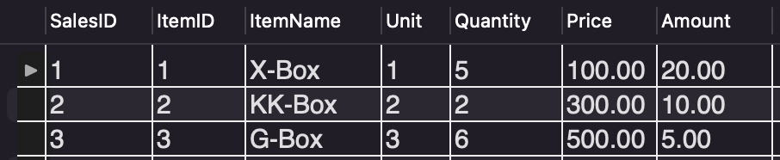

-- VIEW

Create view v_Sales_Order_Detail AS select SalesID, ItemName, Quantity, Price from Sales_Order_Detail;

-- Query all rows of column from v_Sales_Order_Detail and present

Select * from v_Sales_Order_Detail;

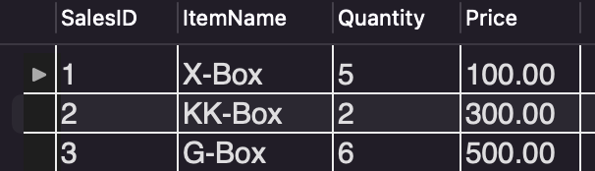

-- A kindly Reminder:

/*

The rows of column that developer does query the VIEW table (i.e., v_Sales_Order_Detail), is completely from the original data of Table: Sales_Order_Detail. Developer CANNOT add or delete the data from original table.

*/